Supplementary Figure 1. Frequency of monthly microscopy results
a. Number of visits among 1674 infants with microscopy test results in at least one month

b. Age-specific distribution for 1264 infants having eight or more microscopy tests

Supplementary Figure 2: Parasite densities for asymptomatic infections and symptomatic malaria in 1674 infants
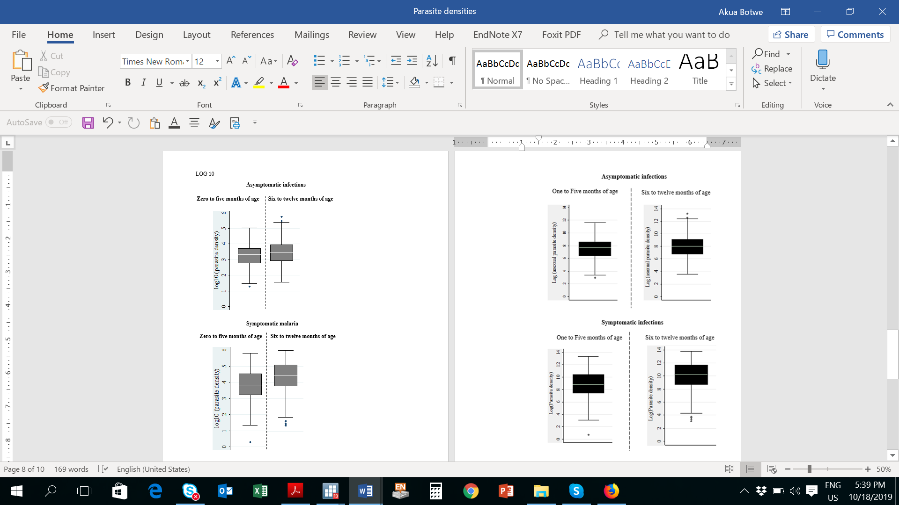

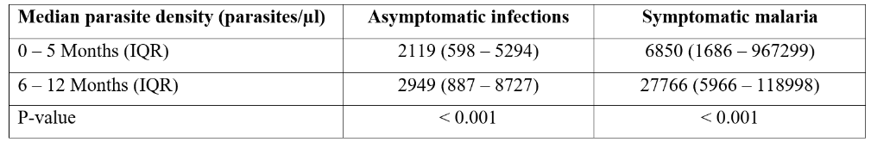

Supplementary Figure 3. Time to an additional infection

